DBMS – LAB -09

**NAME** : RAHUL VARMA

**ROLL NO**: S20200010212

**SECTION**: C

**TASK:** (LAB EXERCISES)

SQL COMMANDS:

Topic: STORED FUNCTIONS

AND ERROR HANDLING

1. Create a function that returns the **customer occupation** based on the **age**.

Age>=35, Carpenter

20<age>=30< Actor

30<age>35 Engineer

Below 20 years student

CREATING A TABLE:

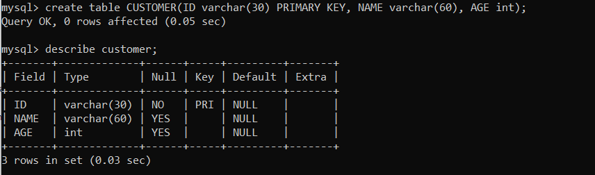

INSERTING VALUES IN THE CUSTOMER TABLE:

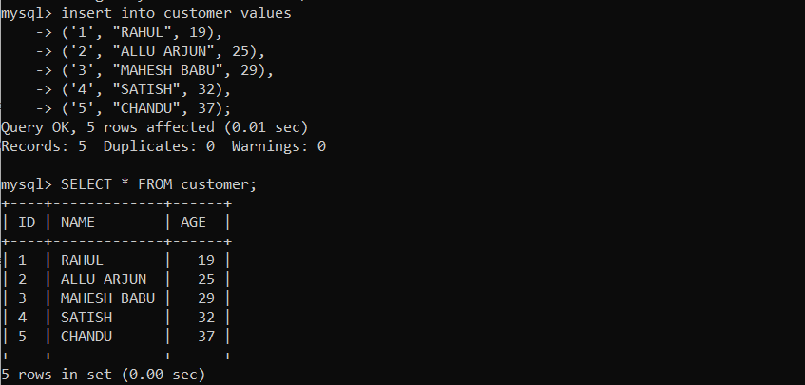

CREATING FUNCTION FOR STORED FUNCTIONS:

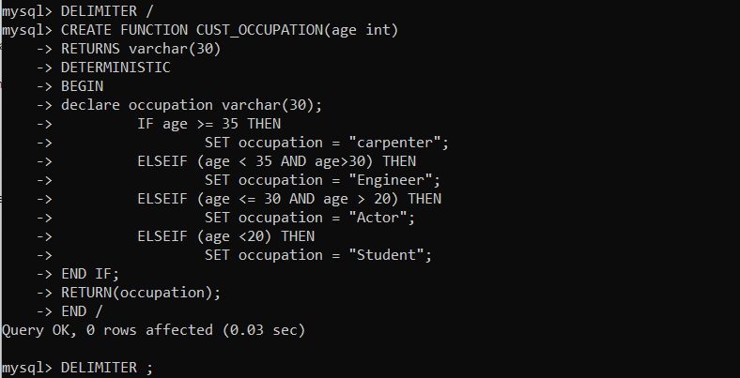

USING THE CREATED FUNCTION:

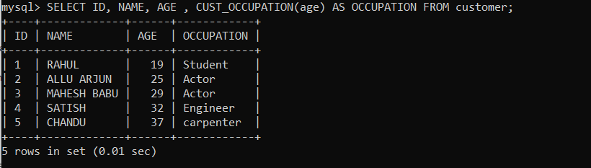

2. Declare an error handler for customer table whenever user inputs the customer’s age above 100 years.

ALTERING TABLE FOR ERROR HANDLING

AND CREATING ERROR HANDLING USING PROCEDURE:

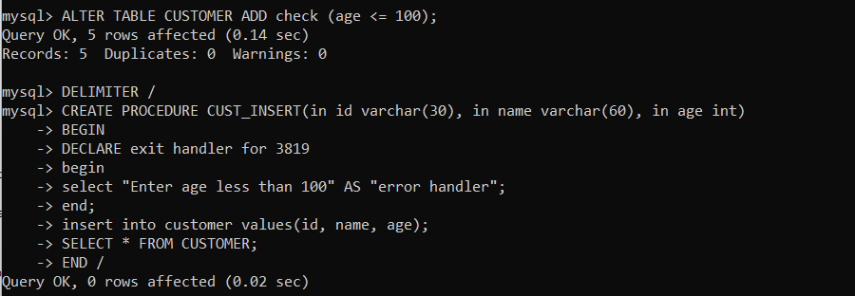

CALLING THE CREATED PROCEDURE:

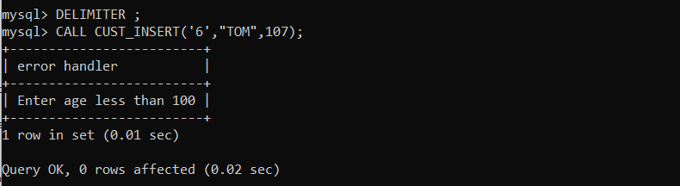

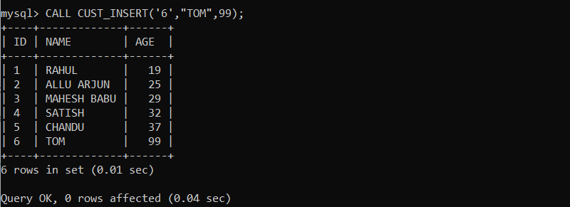

3. Create a function to calculate the age of the all customers based on DateOfBirth(For this program, alter the customer table such that, remove “age” column and add ”dob” column)

ALTERING TABLE ACCORDING TO THE QUESTION:

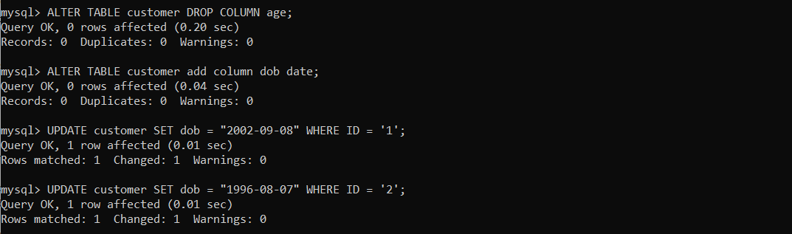

ADDING DOB VALUES FOR EACH RECORD:

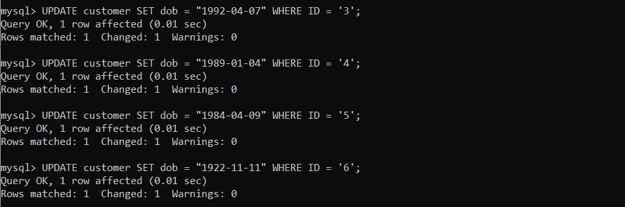 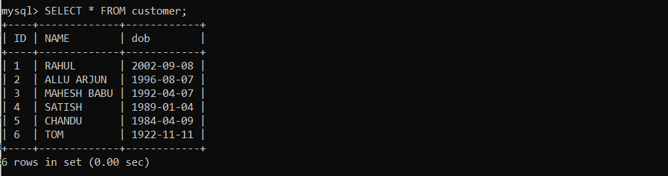

FUNCTION:

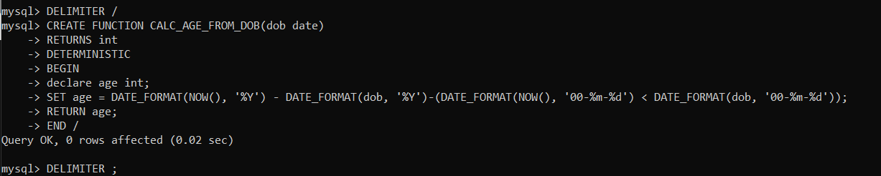

AGES FROM THE DOB:

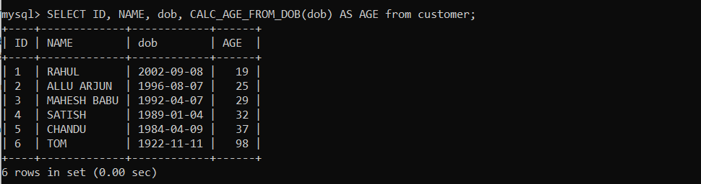

4. Create an error handler that terminates the stored procedure whenever a duplicate key occurs and list out the number of customers who are majors.

PROCEDURE: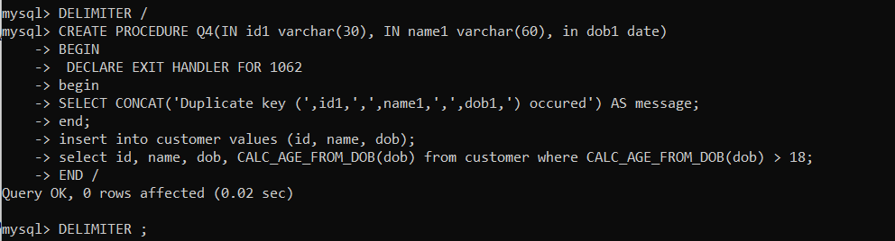

CALLING PROCEDURE AND CALLING AGAIN SAME PROCEDURE:

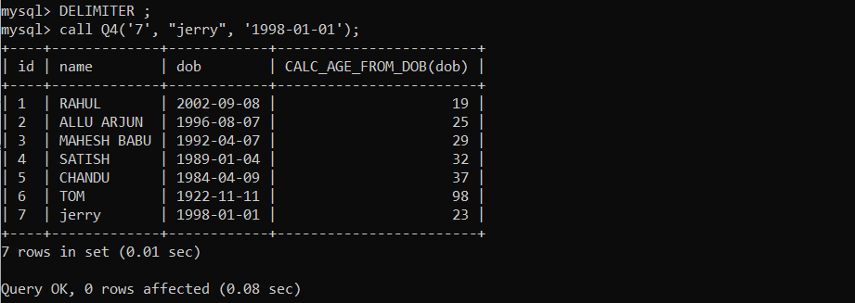 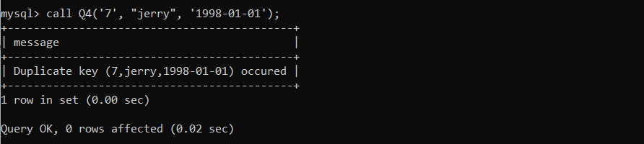

ONLY ONCE THE RECORD IS ENTERED:

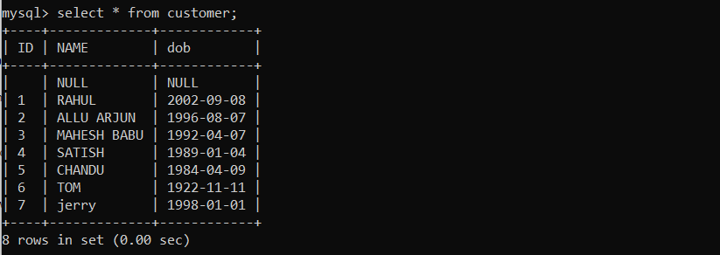

5. Consider a table with the schema BankCustomers (accNum, name and loan). Raise an exception when the customer initiates loan amount above

CREATING PROCEDURE:

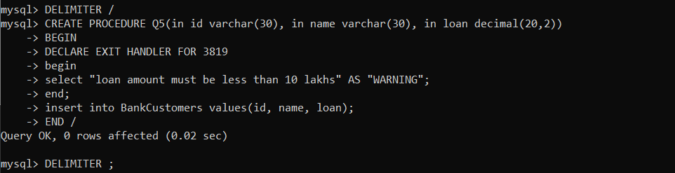

CALLING PROCEDURE:

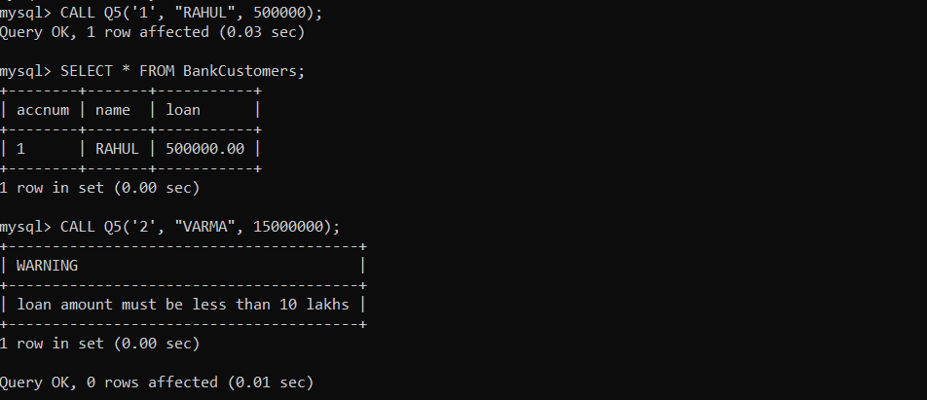

THANK YOU